Lab goals: learn to install and configure Jenkins servers

Requirements: Basic bash and cmd skills, basic Linux and Windows knowledge.

Master installation:  
It’s highly recommended to use Linux-based OS for Jenkins Master.  
It provides you more opportunities for configuring and supporting Jenkins.

>cd /tmp

>wget -q -O - http://pkg.jenkins-ci.org/debian/jenkins-ci.org.key | sudo >apt-key add -  
>sudo sh -c 'echo deb http://pkg.jenkins-ci.org/debian binary/ > /etc/apt/sources.list.d/jenkins.list'  
>sudo apt-get update  
>sudo apt-get install jenkins

When the installation will complete, you can open WebUI by URL: http:your-ip-address:8080

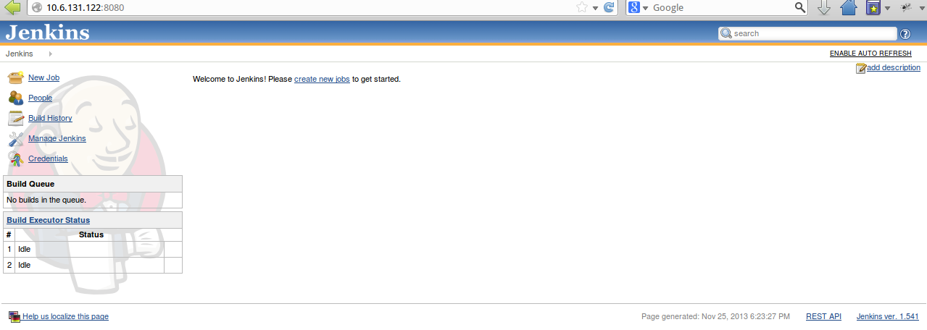

Now you need to add plugins:

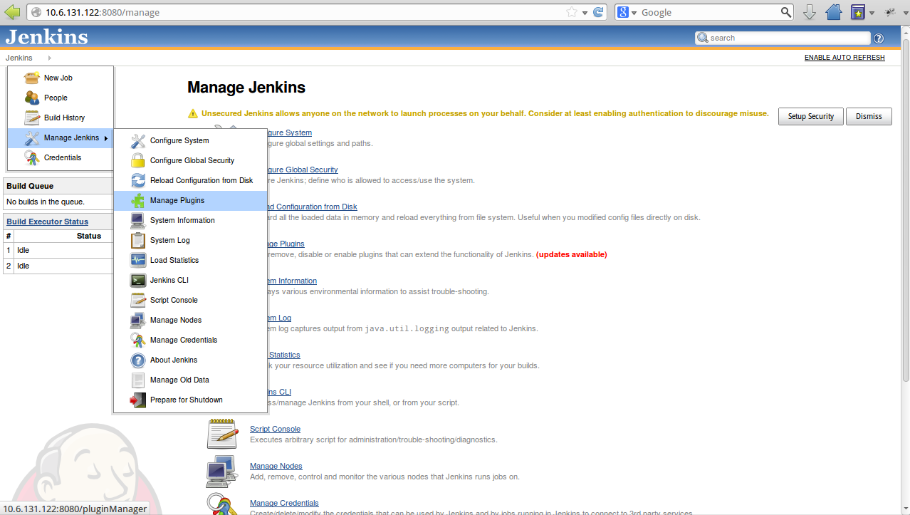

Write “ssh” in menu “Filter” and select plugins “SSH plugin” and “SSH agent plugin“.  
We need these plugins to use Jenkins Linux slave.

Click button “Install without restart”.

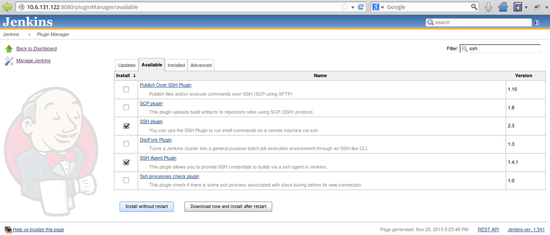

We are going to manage Linux slave via ssh.  
So we need to add special user on Slave and add setup credentials with Master.

Please, login to slave via ssh and perform command “adduser jenkins” and then “passwd jenkins” for setting up the password we will use.

Then, open Master menu in browser.  
Jenkins -> Manage Jenkins - > Manage Credentials -> Add Credentials

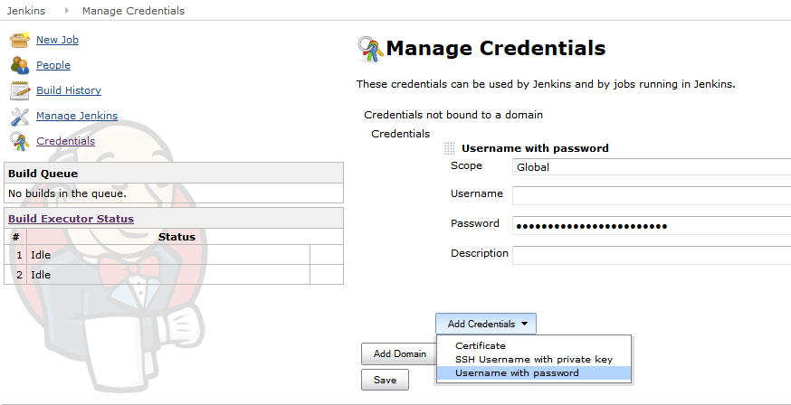

Enter Username “jenkins” and password we created earlier.

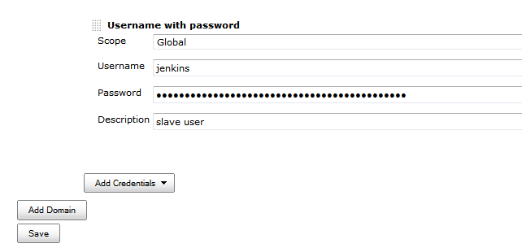

Further we need to install Java on the Linux slave.

You can do this by performing command:  
> apt-get install openjdk-7-jdk

Now we are ready to add first Linux slave.

Open menu Jenkins - > Manage Jenkins - > manage Nodes -> New Node

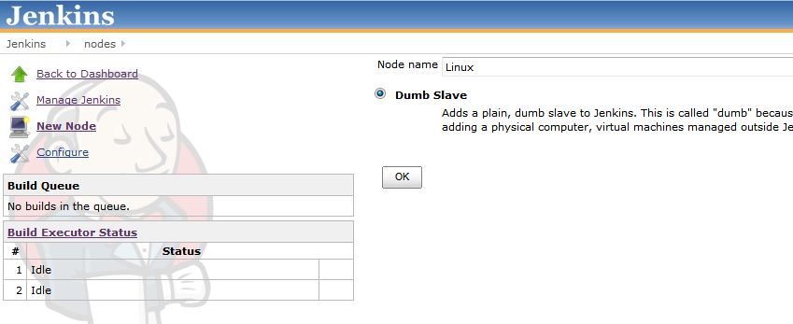

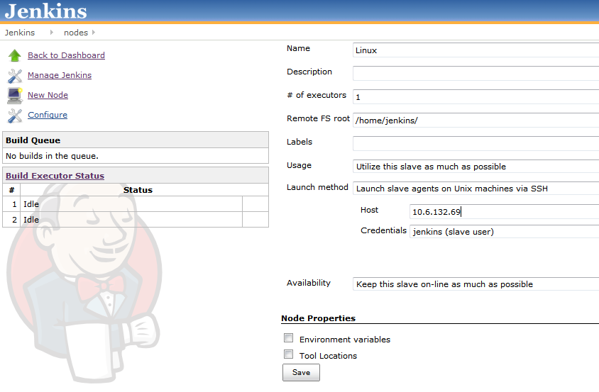

Please specify next options:  
# of executors - the number of concurrent builds that Jenkins can perform

Remote FS root - Home folder of user jenkins.

Usage - Controls how Jenkins schedules builds on this machine

Launch method - how Jenkins starts this slave. In our case this is a ssh.

Host - IP address or DNS name of slave.

Credentials - It has been done earlier.

Availabilty - Controls when Jenkins starts and stops the slave.

After few seconds you can see your Linux slave in menu: Jenkins - > Manage Jenkins - > manage Nodes.

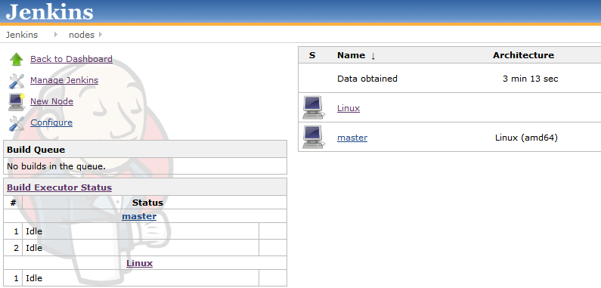

Lets try to add a Windows slave.

Open menu Jenkins - > Manage Jenkins - > manage Nodes -> New Node and create new Dumb Slave with name “Windows_Slave”.

Be sure that name of your slave doesn’t include spaces.

Select a launch method “Lauch slave agents via Java Web Start” and specify Remote FS root.

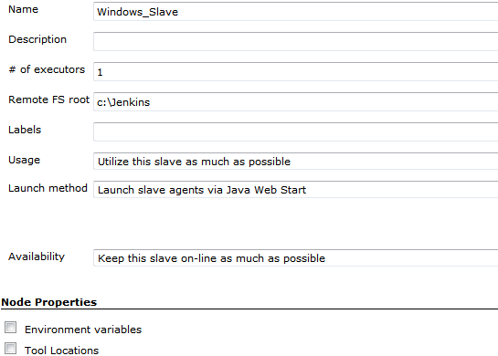

Login to Windows Slave via RDP.

Install java.

Open Jenkins Url in Browser and Open menu Jenkins - > Manage Jenkins - > manage Nodes

Select Windows Slave

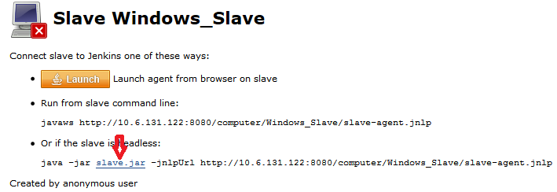

Download file slave.jar and save it to c:\slave for example  
Now we need to create start-script for slave agent.

Content of start-slave.bat:  
java -jar c:\slave\slave.jar -jnlpUrl http://10.6.131.122:8080/computer/Windows_Slave/slave-agent.jnlp

Run the start-slave.bat and don’t close the cmd window.

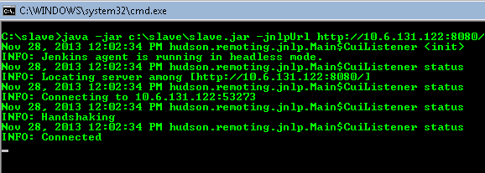

After that you can see your Windows slave is on-line

Open Jenkins Url in Browser and Open menu Jenkins - > Manage Jenkins - > manage Nodes

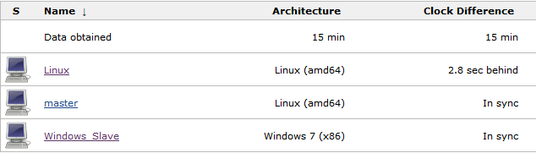

Tasks:

1. Setup Jenkins with two slaves (Linux, Windows)

2. Add plugins to jenkins: maven, msbuild, ssh slaves plugin, ssh

3. Send screenshots from Menu “Installed Plugins” and “Nodes”